**Zomato Data Manipulation and Reporting with Power BI**

* Imported all the files and update below changes in city

“Sí£o Paulo” should be corrected to “São Paulo”

“Cedar Rapids/Iowa City” should be corrected to “Cedar Rapids”

“ÛÁstanbul” should be corrected to “Istanbul”

* Remove columns that aren't being used
* Created two columns to display the **Restaurant Name** and **Restaurant Address**
* Made separate table for the list of the cuisines that each restaurant serves

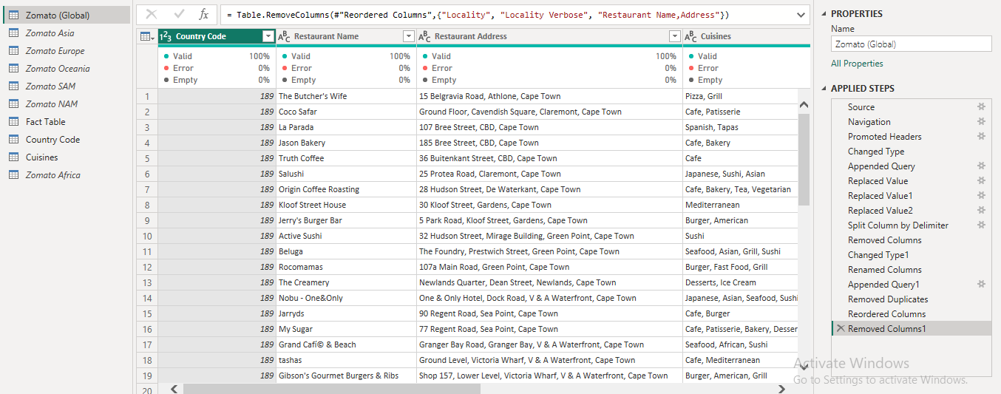

* **Added a Rating color column**

|  |  |
| --- | --- |
| **Aggregate rating** | **Rating color** |
| Above 4.5 | Dark Green |
| 4 to 4.4 | Green |

* Created the following measures in the appropriate tables

a. Restaurant count

b. Average cost

c. Average rating

d. Cuisine count

* Created a new column in the **Country Code** table and name it “**Continent”**

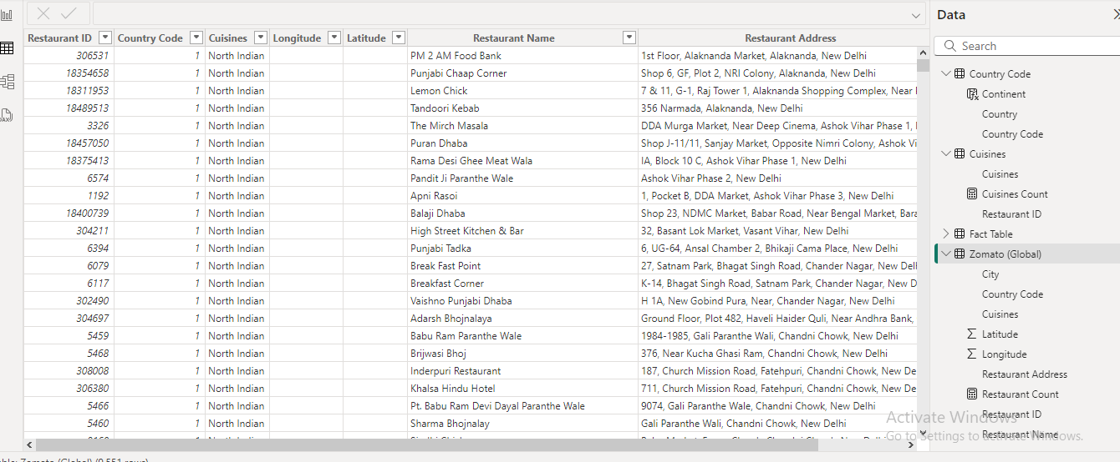

* **Designed a multi-page report that suits Zomato's theme with easy navigation across**

